

Year 11 Specialist Mathematics
Semester 2, August 2021
Test 4: Trigonometric Functions and Identities
Calculator Free
Weighting: 7%
[Australian Curriculum Reference Numbers: 2.1.1 - 2.1.9]
Total Time: 50min Total Marks = $\frac{}{42}$
Student Name:
Teacher: ___________________________________

INSTRUCTIONS TO STUDENTS:
- You are not allowed a calculator or any notes
- A formula booklet will also be provided.

You are required to attempt ALL questions.
Write answers in the spaces provided beneath each question.
Marks are shown with the questions.
Show all working clearly, in sufficient detail to allow your answers to be checked readily and for marks to be answered for reasoning. Incorrect answers given without supporting reasoning cannot be allocated any marks. For any question or part question worth more than two marks, valid working or justification is required to receive full marks.

- Determine the value of the pronumerals for the following graphs.
  - $y=a\sin\left(bx\right)+c$
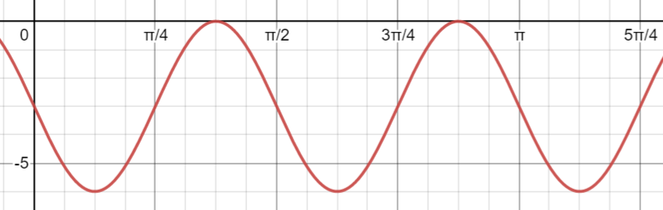
$$a= b= c=$$

  - $y=d cot⁡(x+e)$
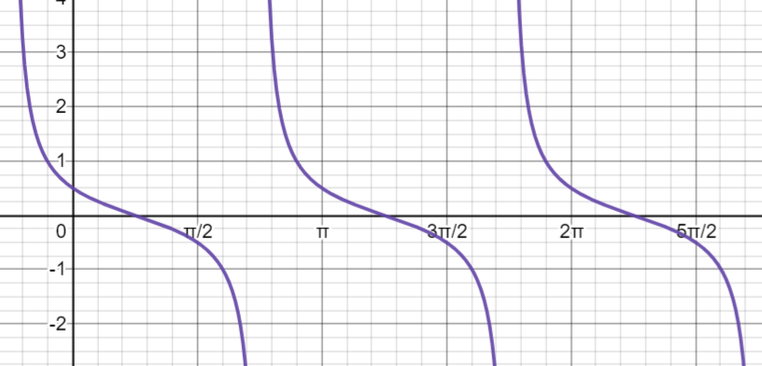
$$d= e=$$

  - $y=f csc⁡( x+g), with-\frac{π}{2} ≤g≤ \frac{π}{2}$
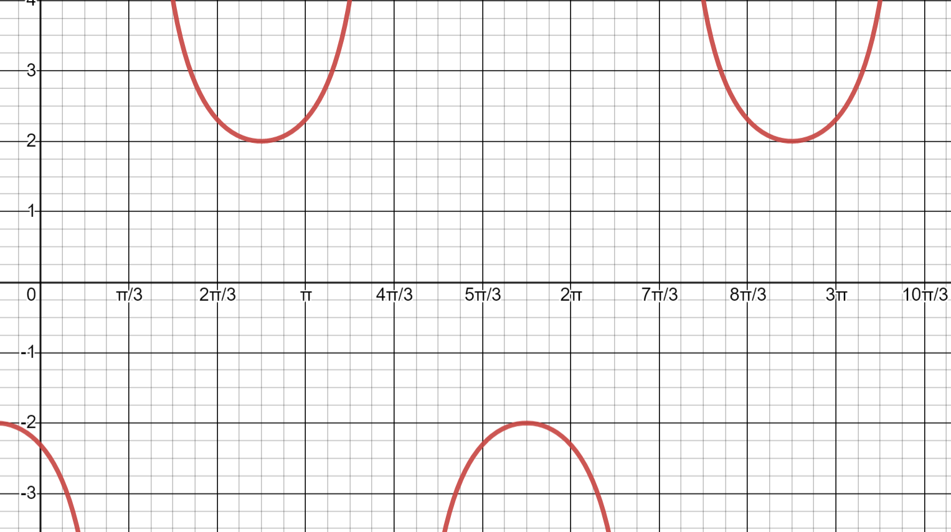
$$f= g=$$
[7 marks]

  - Show that $\tan\left(θ+\frac{π}{4}\right)= \frac{1+tanθ}{1-tanθ}$

  - Hence, prove that $\tan\left(θ+\frac{π}{4}\right)= \frac{1+2\sin{θ}\cos{θ}}{1-2\sin^{2}{θ}}$
[2,5 = 7 marks]

- Determine the exact value of $cos ({\frac{11π}{12}})$ . Express your answer with a rational denominator.
[6 marks]

- Solve the following trigonometric equations:
  - $tan\left(2x+\frac{π}{3}\right)=\sqrt{3} , for-π≤x≤π$
  - $6\csc\left(x+60°\right)=\sqrt{72},$as a general solution in degrees.
[7,6 = 13 Marks]

- Express the value of $\sin{75°}\sin{15°}$ as a single fraction.
[3 marks]

- Express $\sin{x}-\sqrt{3}\cos{x}$ in the form $R\sin{(x±∅)}$ and hence sketch the graph of:
$$y=sin{x}-\sqrt{3}\cos{x}$$


[6 marks]

*** End of Test ***
***Extra space for working out***
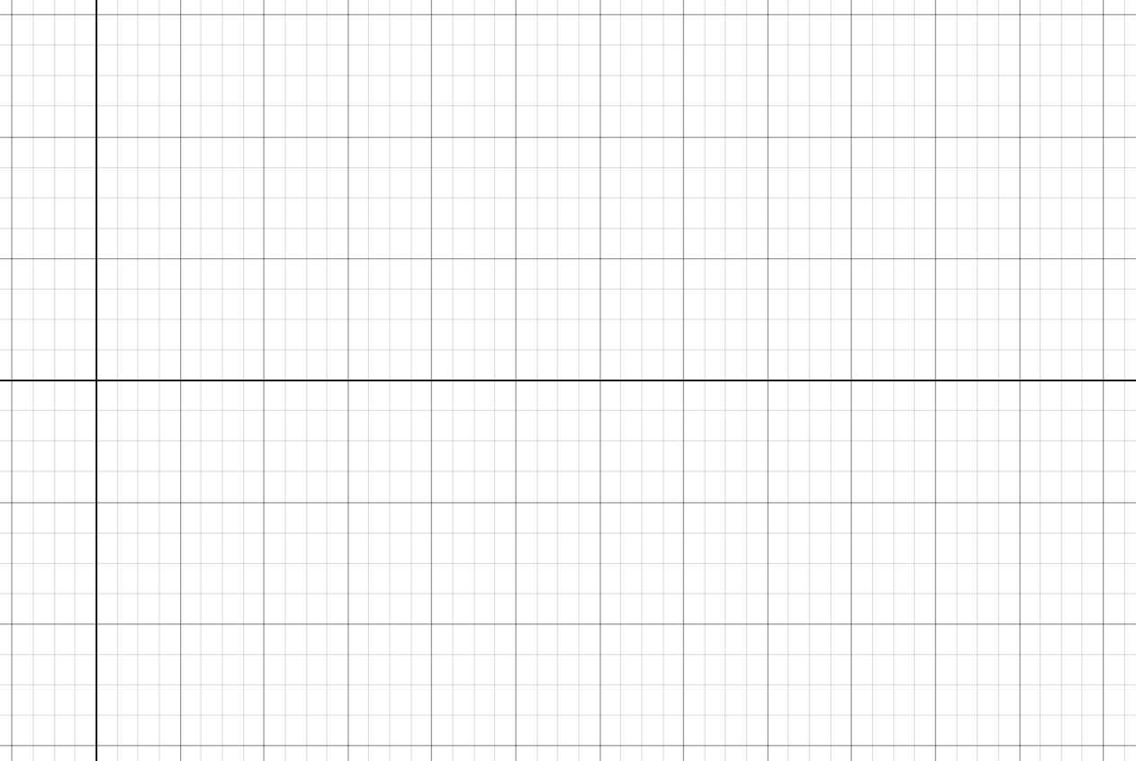

***Extra space for working out***


